SPRINT 1
STAGGING TABLES:
- CDR_RAW_TELECOM
- CUSTOMER_MASTER
- TOWER_MASTER
CDR_RAW_TELECOMMAP_STG_CDR
CREATE TABLE STG_CDR (
Call_ID INT,
Caller VARCHAR(15),
Receiver VARCHAR(15),
Duration INT,
CallType VARCHAR(10),
TowerID VARCHAR(10),
Timestamp_Str VARCHAR(50)
);
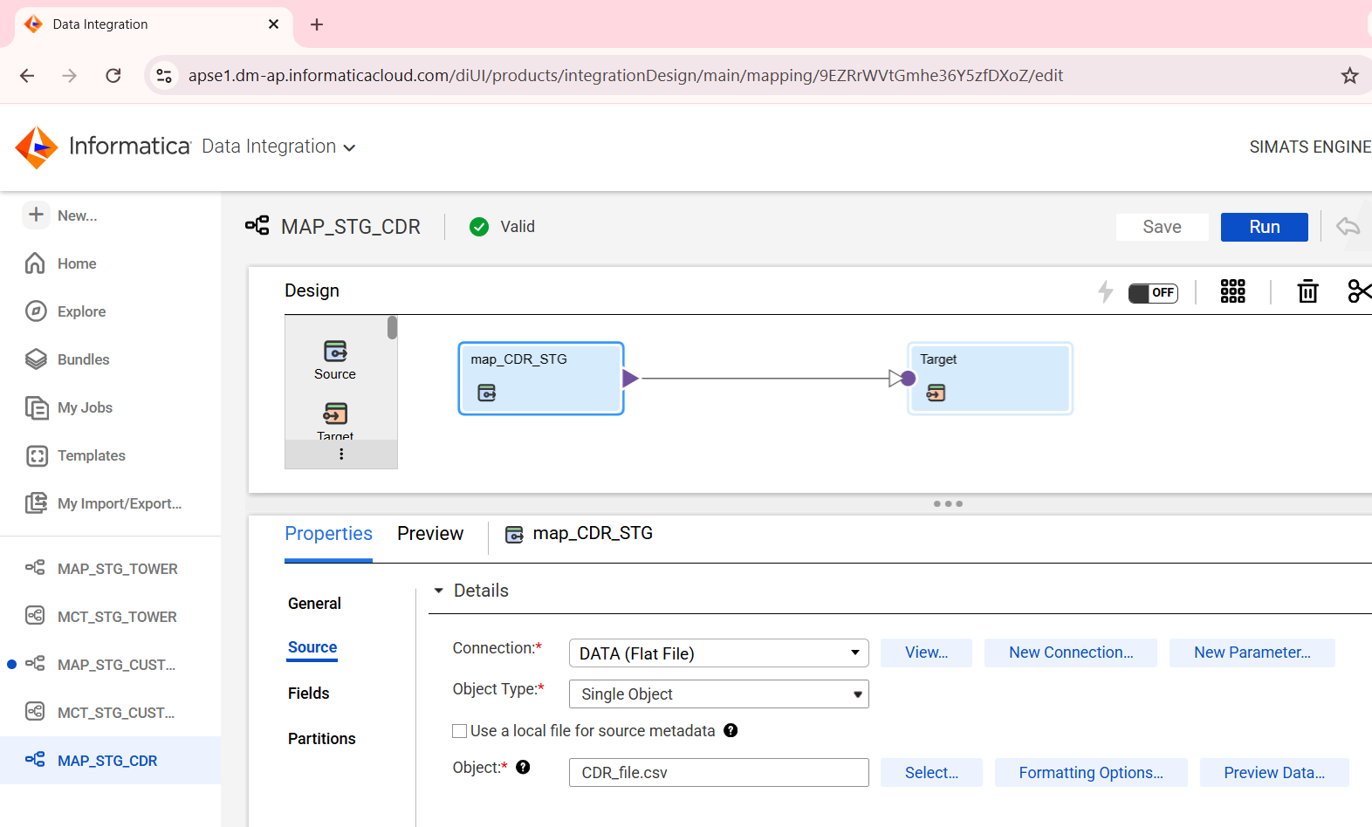
FIG1: “This mapping loads Call Detail Record data from a flat file CDR_file.csv into a staging table. It is a simple source-to-target mapping without transformations, used for initial data ingestion.”
TOWER MASTERSTG_TOWER
CREATE TABLE STG_TOWER (
TowerID VARCHAR(10),
Region VARCHAR(50),
City VARCHAR(50)
);
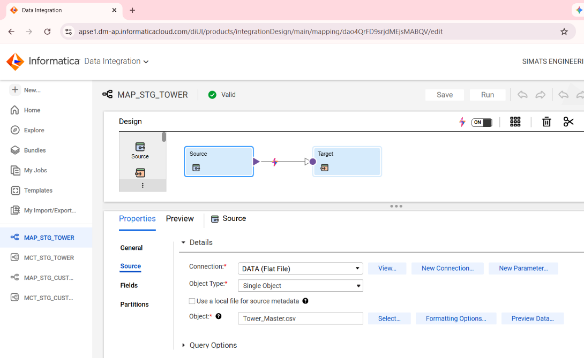
FIG2: “This mapping loads data from a flat file (Tower_Master.csv) into a staging table using a simple Source-to-Target flow without any transformations.”

CUSTOMER_MASTERMAP_STG_CUSTOMER
CREATE TABLE STG_CUSTOMER_HACKK (
PhoneNumber NUMBER(15),
CustomerName VARCHAR(100),
PlanType VARCHAR(20),
TowerID VARCHAR(10)
);
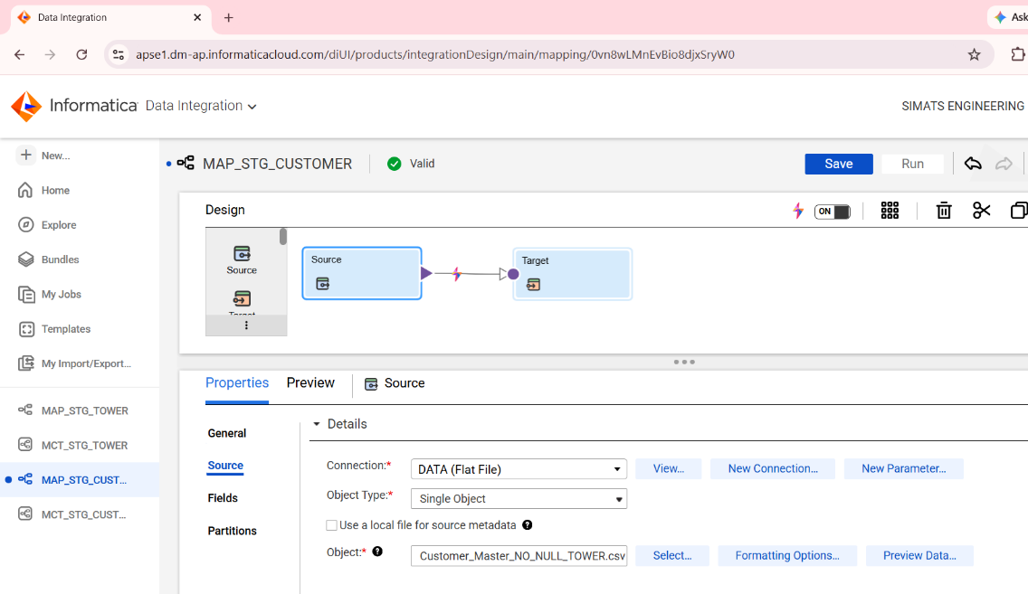

FIG 3: “This mapping loads customer data from a flat file Customer_Master_NO_NULL_TOWER.csv into a staging table. It is a simple source-to-target mapping without transformations, used for initial data loading.”

DIMENSION TABLE
DIM_DATE
CREATE TABLE DIM_DATE (
DATE_KEY NUMBER(8) PRIMARY KEY,
FULL_DATE DATE,
DAY_NUM NUMBER(2),
MONTH_NUM NUMBER(2),
MONTH_NAME VARCHAR2(20),
QUARTER_NUM NUMBER(1),
YEAR_NUM NUMBER(4),
WEEK_DAY VARCHAR2(20)
);
DECLARE
v_start_date DATE := DATE '2024-01-01';
BEGIN
FOR i IN 0..2190 LOOP -- ~6 years
INSERT INTO DIM_DATE (
DATE_KEY,
FULL_DATE,
DAY_NUM,
MONTH_NUM,
MONTH_NAME,
QUARTER_NUM,
YEAR_NUM,
WEEK_DAY
)
VALUES (
TO_NUMBER(TO_CHAR(v_start_date + i, 'YYYYMMDD')),
v_start_date + i,
EXTRACT(DAY FROM v_start_date + i),
EXTRACT(MONTH FROM v_start_date + i),
TRIM(TO_CHAR(v_start_date + i, 'MONTH')),
TO_NUMBER(TO_CHAR(v_start_date + i, 'Q')),
EXTRACT(YEAR FROM v_start_date + i),
TRIM(TO_CHAR(v_start_date + i, 'DAY'))
);
END LOOP;
COMMIT;
END;
/
--Step 1: Create the Table
-- Step 2: Declare Start Date
DECLARE
v_start_date DATE := DATE '2024-01-01';
-- Step 3: Begin PL/SQL Block
BEGIN
--Step 4: Loop Through Dates
FOR i IN 0..2190 LOOP -- ~6 years
Loop runs 2191 times (~6 years)
- i = 0 → 01-Jan-2024
- i = 1 → 02-Jan-2024
- … continues day by day

--Step 5: Generate Each Date
- v_start_date + i,

--Step 6: Insert Data into Table

INSERT INTO DIM_DATE (...)

VALUES (...)

Step 7: Generate DATE_KEY

TO_NUMBER(TO_CHAR(v_start_date + i, 'YYYYMMDD'))

Step 8: Extract Day,month,year

EXTRACT(DAY FROM v_start_date + i)

EXTRACT(MONTH FROM v_start_date + i)

EXTRACT(YEAR FROM v_start_date + i)

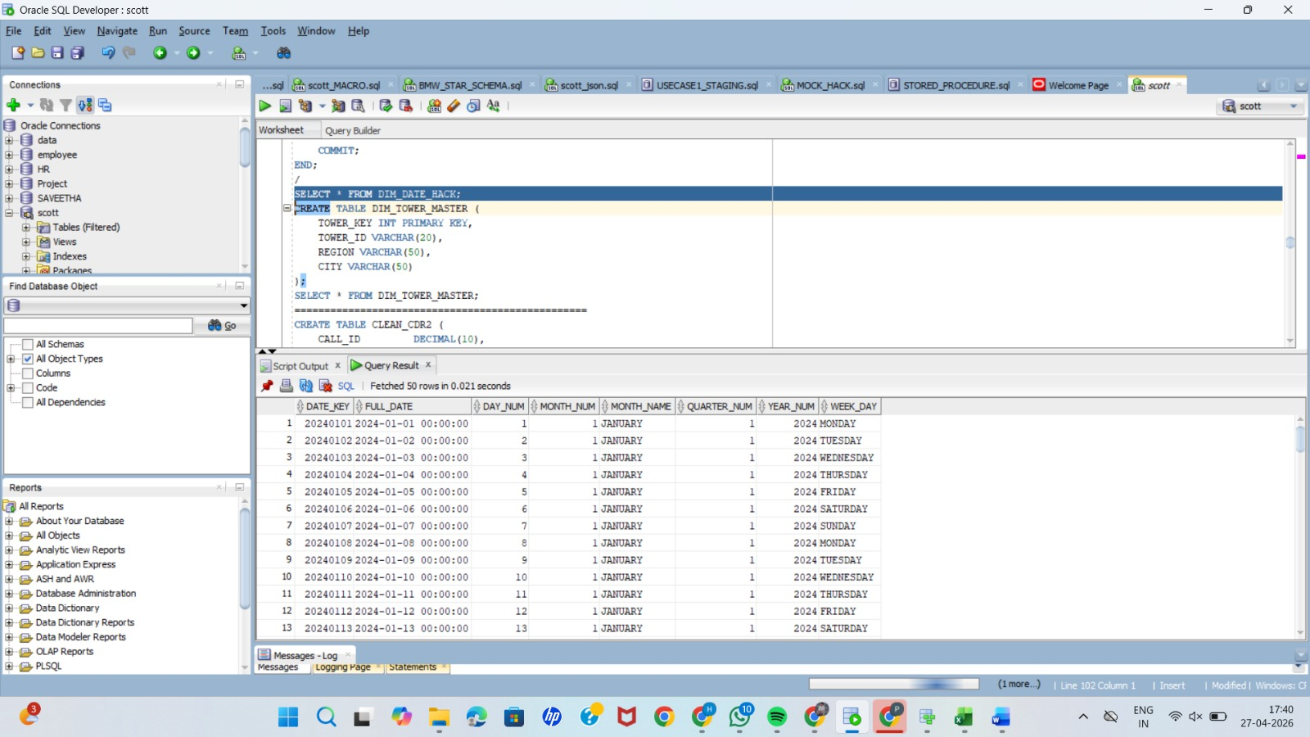

USE CASE--5

EMAIL ALERT NOTIFICATIONS

“In addition to core ETL, I implemented enhanced features like email alert notifications using an Email Task in the workflow, triggered conditionally after identifying high usage customers through expression and Router transformations.”

MAPPING:

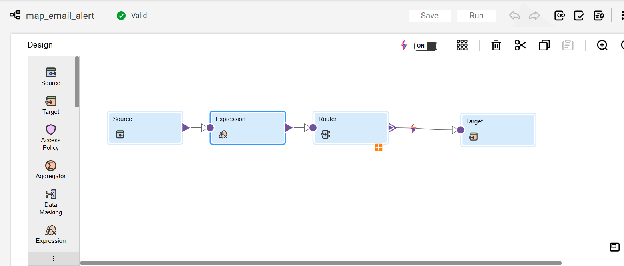

Expression:
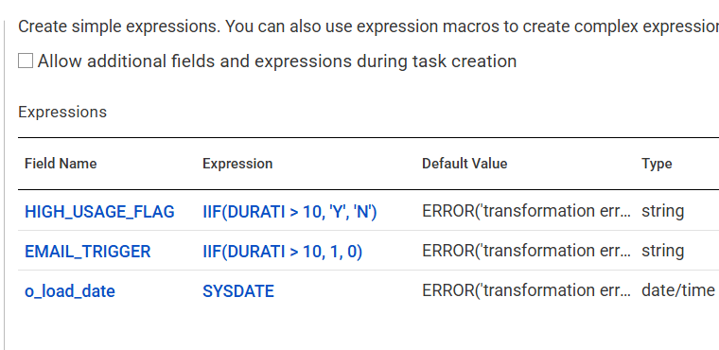
Router:
